A summer training project report on

**IOT BASED LOW-VOLTAGE AUTOMATION**



16/06/22 to 29/07/22

**Submitted by: Shalini Siddhi Guided by: Shrinjoy Bagchi**

B.Tech undergraduate (3rd year) HoG - P&T- Distribution

Electronics and communication engineering protection and automation

Jaypee university of information technology Tatapower-ddl

**APPROVED APPLICATION FOR INTERNSHIP**

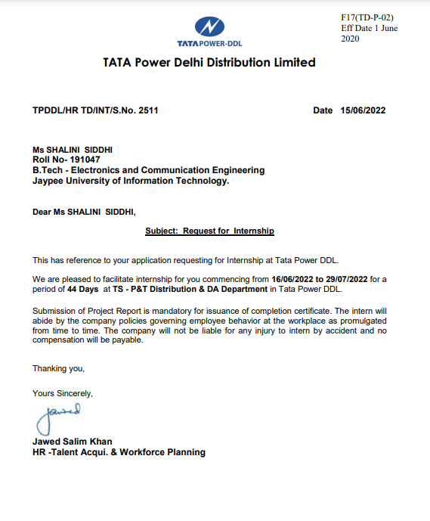

**ACKNOWLEDGEMENT**

Various factors, situations, and person integrate to provide the background for  accomplishment of a task. Several persons with whom we interacted have  contributed significantly to the successful completion of the Project Study.  I express my sincere thanks to **Mr Shrinjoy Bagchi** (HoG - P&T- Distribution Protection & Automation),my mentor at **TPDDL** for his active support and continuous  guidance without which it would have been difficult for me to complete this project.

I am also thankful to my project mentor**, Ms Anuradha Kumari(**Distribution Protection & Automation)for taking out time from her busy schedule and helping me in my  project.

I am grateful to **Mr Priyank shekhar(**Sr. manager) for helping me get through the logics and working of LTACB.

I owe my wholehearted thanks and appreciation to the entire staff of the company for their assistance and cooperation during the course of my project.

I hope that I can build upon the experience and knowledge that I have gained and make a valuable contribution towards this industry in coming future.

**Name:**

Shalini Siddhi

BTECH,ECE

JUIT,SOLAN

**ABOUT THE COMPANY**

**Tata Power Delhi Distribution (Tata Power-DDL),** a joint venture between Tata  Power and the Government of NCT of Delhi, has been the frontrunner in  implementing power distribution reforms in the capital city and is acknowledged  for its consumer-friendly practices.

It is the first power distribution company in India to report profits and present  dividend earnings to its joint owners, the state government of Delhi and Tata Power.  And it is the first power distribution utility from India to win the prestigious Edison  Award (twice) for outstanding contributions to the advancement of the industry  worldwide. Most importantly, it represents a successful working model for future  public-private initiatives.

TPDDL, earlier named North Delhi Power (NDPL), which services the north and  northwest areas of Delhi, began operations in July 2002. Since privatization, the  Aggregate Technical & Commercial (AT&C) losses in Tata Power-DDL areas have  shown a record decline. AT&C loss is a measure of overall efficiency of the  distribution business which is the difference between units’ input into the system

and the units for which the payment is collected.

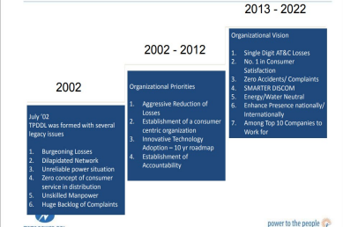

**Figure 1 Year-Wise Company's Target**

In the years since, it has brought  AT&C losses down from 53% to 12%, beating the world average of 15%.

TPDDL is moving forward to achieve following targets-:

• To provide best and economical distribution of power.

• To ensure customer satisfaction.

• To make environment of co-operation and knowledge.

• To ensure fulfillment of expectations of partners.

Apart from this, Tata Power Delhi Distribution Limited also works on various  projects to preserve and regenerate the environment. It is a member of the Greening  Agency within the Department of Forest & Wildlife, Government of Delhi and is  committed to promote tree plantation. Tata Power-DDL has been aggressively  creating energy conservation awareness though its Energy Club programmers  comprising of students from over 340 member schools. More than 2.5 lakh students  and 12.5 lakh people have been sensitized to the issues of Climate Change through  this initiative and have saved nearly 17.46 lakh units of electricity.

.

**Approach to way Forward**

With Increasing focus of Utilities on Automation and adoption of IIOT based  solutions to fulfil their IT-OT business objectives of achieving and complying all  Service Levels of Automation which include: -

1. SL1: - Grid Substations OT devices

2. SL2: - Zonal Switching Stations Distribution Automation Devices  3. SL3: - LV Automation (Feeder pillar automation or ACB automation).  4. DER: - Distributed Energy Resources integration with existing Grids for  e.g., Solar roof tops, Wind, Captive plants etc.

5. AMI: - Advanced metering infrastructure. Smart Meters deployment and  integration with HES / MDM and SCADA / ADMS.

6. Communication Infrastructures like RF Canopy, Cellular Modems and  IP/MPLS panels.

In addition, there is also a huge pressure on Indian Utilities for Smart Grid  compliance. In simplest definition, there are projections that many more numbers  of OT devices will be deployed in all verticals of Power Grid Networks for real  time information exchange and advanced big data analysis.

A future Power Grid will be a complex system with two -way flow of electricity &  information with multi-dimensional deployment of OT IEDs for e.g.:

• Multi layers sensors, Analog to Digital converters, High end transducers  • Advanced Telemetry and Communication solutions like Optical, RF,  Cellular, IIOT based

• High end computing processors, algorithms, servers

**PREFACE**

In order to improve the operational safety and market operation efficiency of the prosumer energy community, to achieve comprehensive monitoring of abnormalities, fault alarms, and intelligent control and maintenance, to reduce the risk of information security, and to address the many types of operational testing and metering equipment in the prosumer community, the duplication of functions and hardware composition was performed, resulting in the waste of resources of monitoring and metering equipment. In the meantime, we proposed an intelligent perception device-based IoT platform architecture for power distribution communities by integrating the software and hardware of the original operation monitoring and metering equipment of the prosumer-integrated communities.

The intelligent perception device for community IoT sensing was first introduced, and then, the operation monitoring and metering equipment in the distribution station area was integrated and optimized to enhance the panoramic state sensing capability of the intelligent terminal; the expansion application direction of data-driven distribution IoT was proposed from the typical application scenario of the terminal.

The low-voltage distribution community actively carries out applications such as station operation status monitoring, camping and distribution data interaction, and new energy coordination and control through station area intelligent perception devices based on real-time status data collection to achieve observable and controllable operation status of the low-voltage distribution network, which provides strong support for lean control of the distribution network. The cloud center is responsible for data mining and advanced business processing, and the edge computing terminal is responsible for data collection and local processing to meet the real-time requirements of business, and the cloud-edge collaboration mechanism provides an effective solution for in-depth analysis of power big data.

**TABLE OF CONTENTS**

1. **Introduction**
2. **Overview and scope of IoT**
   1. What is IoT?
   2. Characteristics of IoT
   3. Application domains
   4. IoT protocols
   5. IoT standards
   6. Industry 4.0 and IoT
   7. Advantage of IoT over conventional automation
3. **Automated LV network**
   1. Existing scenario
   2. Proposed solution
   3. LV automation architecture
   4. Specification for IoT based LV automation device
   5. Key features of IoT based LV automation device
   6. LV Automation webpage description and photographs
   7. LV automation site photographs
   8. LV automation X-CTU website for troubleshooting
4. **Benefits of IoT in LV automation**
   1. MTTR reduction
   2. Predictive analysis
   3. Improves SAIDI
   4. Fault prediction
5. **Conclusion**
6. **References**

**LIST OF FIGURES**

* 1. IoT block diagram and architecture

2.1 Different protocols in IoT

2.2 IoT and industry 4.0

3.1 LV automation architecture at TPDDL

3.2 key features of IoT based LV automation device

3.3 LT ACB hardware block diagram

3.4 IoT based LT ACB automation device configuration

3.5 District wise LTACB/Fuse Alerts

3.6 Exported device data sheet

3.7 MTTR bar graph for LTACB tripping

3.8 Top 5 tripping zones

3.9 Online/offline device count

3.10 pin mapping

3.11 Device details

3.12 Device latest health status

3.13 Device summary

3.14 Master mapping hierarchy

3.15 IoT device troubleshooting

3.16 LT ACBs

3.17 Live IoT device at the site

3.18 Distribution transformer

3.19 Terminal and command window

3.20 Network Strength and device UUID

3.21 Running file to check published and received sensor data

**LIST OF TABLES**

1. IoT applications and vulnerability
2. key technology factors enabling IoT adoption in India
3. command list for X-CTU

**1.INTRODUCTION**

Economic efficiency and permanent availability of the electric energy from the generation to the consumer - these are requirements which the power supply utilities and industry have to tackle worldwide. Intelligent solutions are in demand to meet these requirements. A successful automation system is the foundation for a high level of functionality and flexibility. Naturally, that also includes comprehensive options for telecontrol, communication and for connecting peripheral equipment. Industry is on the threshold of the fourth industrial revolution. Automation is now being followed by the digitalization of production. The aim: to increase productivity and efficiency, speed, and quality. In this way, companies can remain competitive on the path to the future of industry.

LV automation is one of the challenging and important aspect in distribution automation among power industries in India. Conventional automation have been a blessing to automation but IoT provides more open standards, more interoperability, more ease in adding and modifying installations, and access to cloud-based resources. In this project TPDDL is going to imply LV automation using IoT device to ensure proper monitoring and required customer satisfaction in electrical distribution system. IoT device is integrated with ADMS (Solution to design, analyze and operate electrical power distribution networks. Integrated distribution planning, GIS, electrical SCADA, DMS & OMS) to provide protection to automated distribution.

**2.OVERVIEW AND SCOPE OF IOT**

**2.1 What is IoT?**

Current IEEE Definition (Low complexity system)

• An IoT is a network that connects uniquely identifiable “Things” to the Internet

• The “Things” have sensing/actuation and potential programmability capabilities

• Information about the “Thing” can be collected and the state of the “Thing” can be changed from anywhere, anytime, by anything.

The Internet of things (IoT) describes the network of physical objects - "things" - that are embedded with sensors, software, and other technologies for the purpose of connecting and exchanging data with other devices and systems over the Internet.



Fig 1.1 IoT block diagram and architecture

**2.2Characteristics of IoT**

* + Massively scalable and efficient
  + An abundance of physical objects is present that do not use IP, so IoT is made possible.
  + Devices typically consume less power. When not in use, they should be automatically programmed to sleep.
  + Self-configuring
  + Intermittent connectivity – IoT devices aren’t always connected. In order to save bandwidth and battery consumption, devices will be powered off periodically when not in use. Otherwise, connections might turn unreliable and thus prove to be inefficient
  + Dynamic and self-adapting
  + Interoperable communication protocols.
  + Unique identity
  + Integrated into the information network

**2.3 Application Domains:**

IoT is currently found in four different popular domains:

1) Manufacturing/Industrial business - 40.2%

2) Healthcare - 30.3%

3) Security - 7.7%

4) Retail - 8.3%

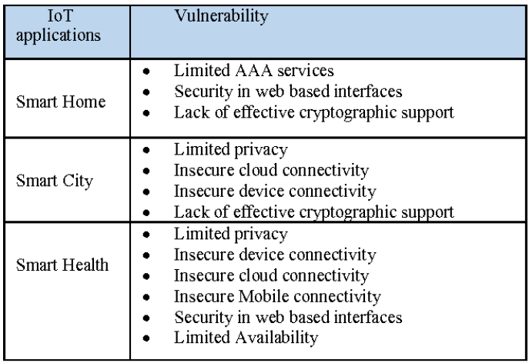

Table 1 IoT applications and vulnerability

**2.4 IoT protocols**

1. Link Layer- The data layer is the part of an IoT protocol that transfers data within the system architecture, identifying and correcting errors found in the physical layer.

• 802.3 – Ethernet

• 802.11 – WiFi - Wi-Fi/802.11 is a standard in homes and offices. Although it is an inexpensive option, it may not suit all scenarios due to its limited range and 24/7 energy consumption.

• 802.16 – WiMax

• 802.15.4 – LR-WPAN - A radio standard for low-powered wireless connection. It is used with Zigbee, 6LoWPAN and other standards to build wireless embedded networks.

• 2G/3G/4G

1. Network/Internet Layer - The network layer of an IoT protocol helps individual devices communicate with the router.

• IPv4

• IPv6

• 6LoWPAN- This IoT protocol works best with low-power devices that have limited processing capabilities.

1. Transport Layer

• TCP- The dominant protocol for a majority of internet connectivity. It offers host-to-host communication, breaking large sets of data into individual packets and resending and reassembling packets as needed.

• UDP- A communications protocol that enables process-to-process communication and runs on top of IP. UDP improves data transfer rates over TCP and best suits applications that require lossless data transmissions.

1. Application Layer - The application layer serves as the interface between the user and the device within a given IoT protocol.

• HTTP

• CoAP- A constrained-bandwidth and constrained-network protocol designed for devices with limited capacity to connect in machine-to-machine communication. CoAP is also a document-transfer protocol that runs over User Datagram Protocol (UDP).

• WebSocket

• MQTT- A messaging protocol designed for lightweight machine-to-machine communication and primarily used for low-bandwidth connections to remote locations. MQTT uses a publisher-subscriber pattern and is ideal for small devices that require efficient bandwidth and battery use.

• XMPP

• DDS- A versatile peer-to-peer communication protocol that does everything from running tiny devices to connecting high-performance networks. DDS streamlines deployment, increases reliability and reduces complexity.

• AMQ- A software layer that creates interoperability between messaging middleware. It helps a range of systems and applications work together, creating standardised messaging on an industrial scale.

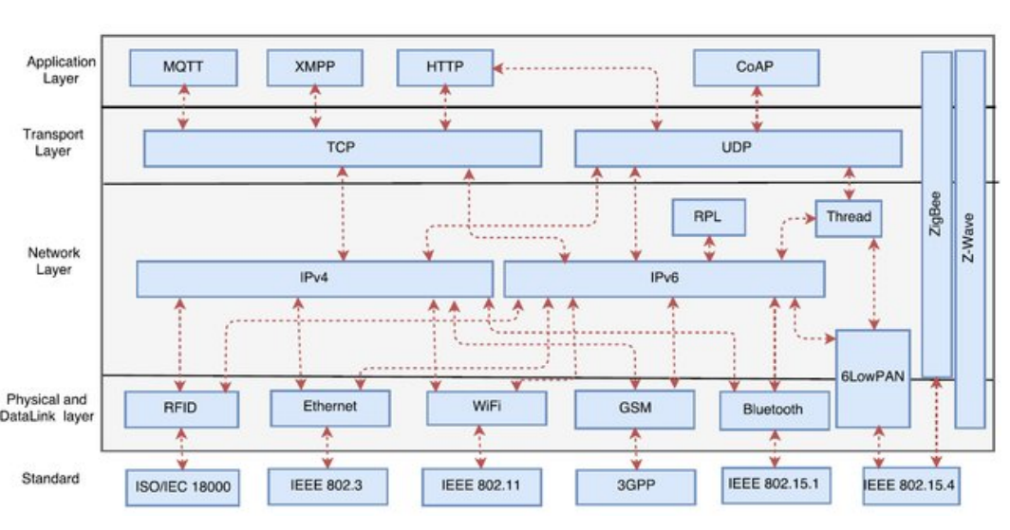

Fig 2.1 Different protocols in IoT

**2.5 IoT standards**

Below are some of the important standards for IoT that helps to ensure the common standards that the IoT enabled devices are supposed to be complied with.

Bluetooth Smart – Bluetooth smart is one of the most important standards of IoT. This standard provides the devices to work using Bluetooth connectivity. Moreover, it makes it possible for the device and the users to communicate or share the instructions using Bluetooth’s simple connection.

ULE – ULE stands for Ultra-low emission. The amount of power involved in this is way too less, as stated by its name. The common telephone network we use at our homework using this standard and the embedded devices leverages it wherever possible in order to facilitate communication with other devices.

IEEE 802.11ah – These standards are concerned with the wifi connectivity that runs on low power. In the internet of things, the devices preferably work with low power consumption mechanism involvement. Though Wifi doesn’t fall under the low power consumption part, this standard is concerned with the lower power consumption of devices. This standard has been considered as the most effective one as the availability of wifi is very common.

Thread – Thread may be considered the best standard that provides the opportunity to leverage IPV6 to make communication over the internet. The ownership of this standard is held by Alpha that is the parent company of Google. It makes the interaction between devices very convenient and smooth. Being handled by Alpha, this standard consists of most of the parts that are concerned with the secure and efficient working of the IoT enabled devices.

ZigBee – This is the other standard that helps to take the IoT to the next level. It has been developed by an organization called the ZigBee industry. The main purpose of this standard is to offer a network of devices that consume less power to function. The common devices that are being used in houses leverage this standard in order to communicate with low power requirements.

Z-Wave – Z-Wave is the most commonly used standard. Similar to the other standards, it is also concerned with working devices that use less power to work well in the network. Sigma Designs own this standard, and the changes or improvements in this standard are taken by this organization only. The outcome of this standard is the low power mesh technology of networking. In almost all smart devices or IoT enabled devices in the USA, this standard is de facto.

6LoWPAN – This is another standard influenced by IEEE. It is concerned with creating the IoT system that consists of devices that are connected to the internet and use less power to facilitate communication. IPV6 has been used in this standard when it comes to connecting the devices that are available on the internet. All of the standards for IoT are concerned about the way devices interact with each other to create the network of the devices.

**2.6** **Industry 4.0 and IoT**

• Industry 1.0 : Mechanization through water and steam power

• Industry 2.0 : Mass production and assembly lines using electricity

• Industry 3.0 : Computerized Automation Sensors and associated decisions SCADA (Supervisory Control & Data Acquisition) MES (Manufacturing Execution System) Revolutions in Industry

* Industry-4.0 Cyber-physical Systems IoT: Complete visualization and Communication using cloud

1. Inventory/ supply chain management ➔Big Data
2. Optimized sharing of Resources services and Revenue
3. Mass customization(FOTA),
4. Democratization of Manufacturing: ➔ Equal opportunity ➔ Shared benefits

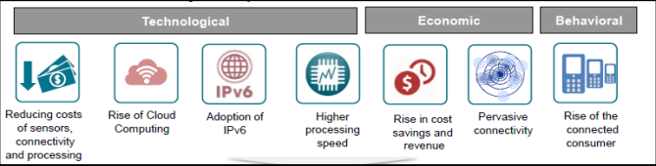

Fig 2.2 IoT and industry 4.0

IoT is a key part of the Industry 4.0 strategy which works to create flexible and connected digital factories where communication is facilitated between all parts of the system.

**Three Benefits of IoT & Industry 4.0**

1. **Predictive Maintenance**

Maintenance is a major headache for any plant manager. The downtime and costs associated with it can prove expensive. The classic approach to regular maintenance is inefficient increases the risk of the breakage and wear of machine tools, which in turn increases costs.

Predictive maintenance systems use IoT to get real-time information about each in-service asset. Based on the information, the system predicts the time for asset maintenance. Manufacturing plants have interconnected systems where multiple factors are at work. Load, design, and process changes at one location can affect the entire plant. IoT-based predictive maintenance and cloud computing find great use in such cases. The system uses data from assets around the plant to predict maintenance requirements.

Predictive maintenance gets special attention due to its effect on the bottom line. According to a McKinsey report, predictive maintenance can reduce cost by 10-40 percent and downtime by 50 percent. These improvements affect plant efficiency and even bring down indirect costs. The digital factories of tomorrow will find predictive maintenance inevitable in order to stay competitive.

1. **Smart Logistics Management**

During the Covid-19 pandemic, the manufacturing sector faced unprecedented conditions including social distancing requirements, worker shortages, and workforce size limits. All of these conditions greatly affected factories and warehouses.

Logistics is the lifeblood of any business. When logistics of multiple sectors faced challenges, the world suffered supply chain disruptions. These huge disruptions demanded a move towards smarter logistics management.

Factories can use IoT in many areas of logistics. Starting from inventory and material handling to internal transportation and shipping, IoT can help improve the accuracy and efficiency of logistics management. The primary way IoT helps in these areas is through real-time location and condition data of the assets. This helps with optimal use and inventory stocking, better asset tracking, and material handling systems, reducing accidents and asset losses. Information about production and shipping can be shared with partners and customers.

Amazon’s warehouses use IoT and robotics to optimize their systems, with humans working in tandem with interconnected robots. The approach of combining humans and tech has made Amazon the leader in warehousing. Other businesses are expected to follow their successful model moving forward. With the growth of Industry 4.0, the predictive maintenance market is expected to grow at a CAGR of 31 percent from 2021 to 2030.

1. **Big Data and Cloud Computing**

Real-time data collection is a key benefit of digital factories and adopting IoT. The sensors on all factory assets collect large amounts of valuable data. This data can provide vital insights into factory performance.

Right now, only a small fraction of the data actually gets utilized in making decisions. These decisions may be related to changes in production, inventory levels, or forecasting. With cloud computing and big data, businesses can generate priceless insights from data.

IoT and CPS in a factory assure you have data from all the systems. Cloud computing converts that data into useful information. With visualization and correlation analysis, issues are identified and a hypothesis is created for causes. Solutions created to solve the issues are implemented to test the hypothesis. AI is used to calculate the impact of changes and an optimum range for parameters. This stream of data and advanced analytics helps decode complicated manufacturing processes and systems.

**2.7** **Advantage of IoT over conventional automation**

1. Real-time data collection

The most important benefit of IoT is the real-time collection of data which means you get all the information at once instead of waiting till the end when everything has already happened. For example, if there is a power outage, then we won’t know until the next day whether our appliances were affected or not. With IoT, this problem gets solved instantly. You don’t need to wait for someone else to tell you what went wrong; you just check yourself.

2. Better customer service

Another great advantage of IoT is better customer service. If something goes wrong with your car, you would want to know immediately so that you can fix it right away. But how does one find out where exactly the fault lies? Well, thanks to IoT, you no longer need to ask anyone because they will automatically inform you through their mobile app or website. So, whenever anything happens, you will always be informed.

3. Improved productivity

As mentioned earlier, IoT allows you to monitor your products/services 24x7. In case of a malfunctioning device, you can take immediate action to rectify the issue. Also, since you are getting instant feedback, you can make changes accordingly before the situation worsens further. Thus, you save both money and resources.

4. Increased security

Since IoT collects huge amounts of data, it becomes very easy to hack into these systems. However, with IoT, hackers cannot access any personal details like credit card numbers, etc., as they only get raw data. Therefore, security is increased significantly. Also, we can make the system more secure and efficient if we have a system with all these things interconnected.

5. Reduced labor costs

One of the biggest benefits of IoT is reduced costs. When you use IoT, you don't need to hire additional staff members to manage your operations. Instead, you can automate many processes using smart apps. All you need to do is set up rules and let the system run itself. By making their devices communicate with each other in an efficient manner, the internet of things aids to be helpful to people in their daily lives-saving energy and costs. Our systems are more efficient when the data is communicated and shared between devices.

6. Expedient operation

All the data pouring in empowers us to do numerous jobs with astounding velocity. For instance, IoT makes automation easy. Brilliant ventures mechanize dreary undertakings, in this way permitting representatives to put their time and exertion into more challenging things.

7. Adjusting to new standards

As IoT is a steadily evolving point, its progressions are negligible contrasted with the other technologies of the innovative world. Without IoT, it would be muddled for us to monitor each one of the most recent things.

Whirlpool, the globally leading manufacturer of home appliances, has been spearheading IoT for years. Their next-generation Internet of Things program has transformed their business model in myriad ways, including failure detection, predictive maintenance, supply chain management, warranty management, and many more. All this has been assisting Whirlpool to focus, disrupt and win in a progressively jammed and complex global appliance market.

8. More business insights

IoT devices help organizations gather data to identify insights about their business, both internally and externally. Retail stores use beacon technology and other IoT devices to redesign their stores based on real-time traffic patterns. Logistics firms can use internet-connected IoT devices to align delivery locations and schedules that make the most efficient use of vehicles and employees.

Businesses that use IoT to drive modernization throughout their organization reduce their time to market for new products or services and amplify their ROI. They'll add value to the business faster and more efficiently because more actionable data from the devices is easily accessible.

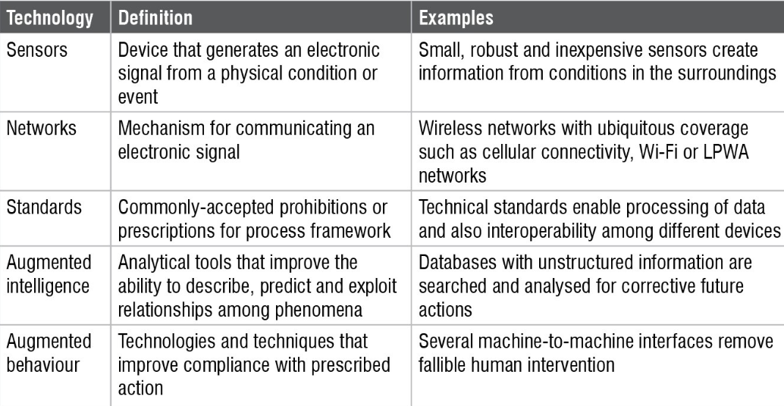

Table 2 key technology factors enabling IoT adoption in India

**3. Automated LV network**

**3.1 Existing scenario**

The current situation is that data collection and storage is on premises and not cloud-based, with limited interoperability, that eventually leads to poor integrability with vendors and inefficient performance.

**3.2 Proposed solution**

With the fast changing world, these latest inventions and innovations will become the norm and it was expected that around more than 30 billion devices will be connected via the Internet by 2020. That’s why we have integrated IoT device with SCADA to increase efficiency and consumer satisfaction.

Hardware

World-class industrial sensors installed on LV network areas. The distribution automation sites will be sharing data over MQTT Protocol using 4G LTE/NB IOT communication to Broker and this will be integrated with Tata Power-DDL Web Portal, ADMS , FFA and Bigdata back end system. MQTT protocol is used for communication as it is ideal for devices that require efficient bandwidth and battery use.

Cloud platform

Analytics platform for all network data. Event based alert generation. Preventive maintenance based on historical data.  Critical parameters will be integrated with Advanced Distribution Management System through web interface as well as Big Data servers.

Enterprise field force application

Ticket-based field force tracking. Real-time event generation from field assets. Management of maintenance activities.  The complete system will be integrated with Web Based Software for real time monitoring and control with facilities for Dashboard, SMS Notifications through SMS Gateway to multiple users , Email Notifications , Daily /Monthly Reports .

**3.3 LV automation architecture**

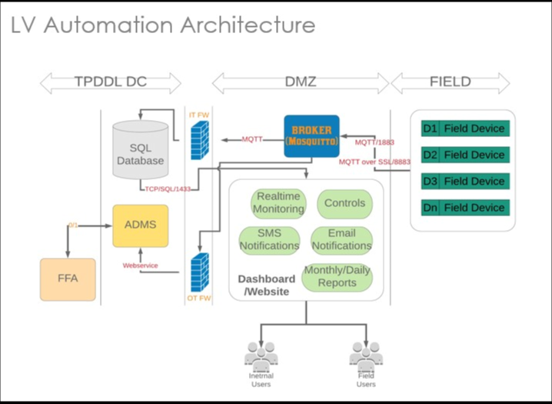

Fig 3.1 LV automation architecture at TPDDL

**3.4** **Specification for IoT based LV automation device**

* ACB Automation Device Lite  Version:

1. 24 Potential Inputs.

2. 8 Potential Free Input.

3. 2 Digital O/P-5A Cont.

4. 2 Modbus Analog Port.

5. Self dialogistic Inputs for  battery health, Signal  Strength, AC Supply Status.

Parameters to monitor:

1. ACB Status.

2. 11 kV RMU Breaker  status.

3. FPI,SF6 Contact status. 4. FPI Reset.

* ACB Automation Device Full  Version:

1. 32 Current Sensors.

2. 8 Potential Free Input.

3. 2 Modbus Analog Port.

4. Self dialogistic Inputs for  battery health, Signal  Strength, AC Supply  Status.

Parameters to monitor:

1. ACB Current.

2. 11 kV RMU Breaker  status.

3. FPI,SF6 Contact status.

4. FPI Reset.

* Pillar Box Automation Device

1. 24 Fuse monitoring  sensor.

2. 2 Potential Free Input.

3. 2 Hotspot Temp. Sensor.

4. Dual Smoke Sensors

5. Self dialogistic Inputs for  battery health, Signal Strength, AC Supply  Status.

Parameters to monitor:

1. 24 Fuse Status.

2. Pillar box inside hotspot  temperature.

3. Cable fire incident.

4. FPI Reset.

**3.5** **Key features of IoT based LV automation device**

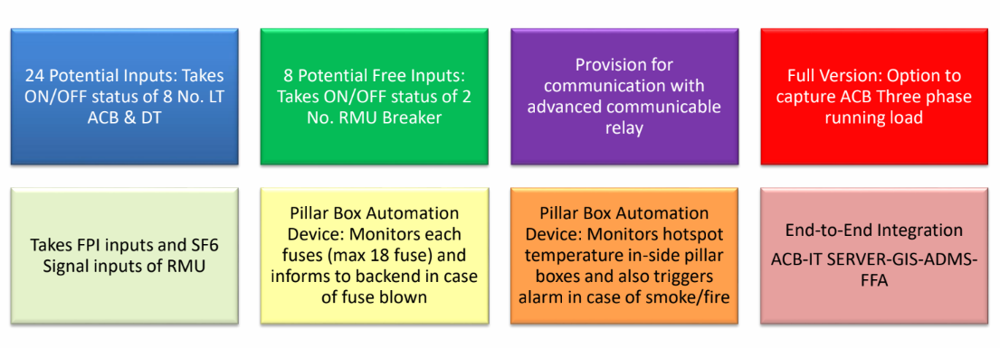

Fig 3.2 key features of IoT based LV automation device

**3.5 LT ACB HARDWARE CONFIGURATION**

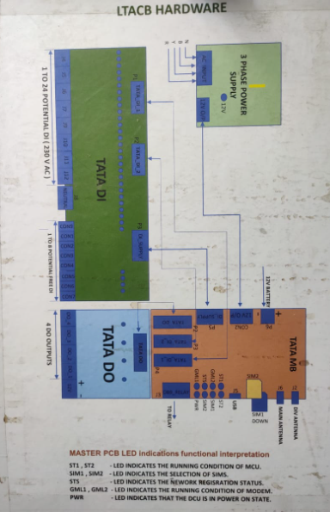

Fig 3.3 LT ACB hardware block diagram

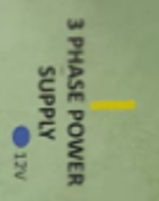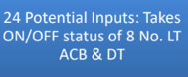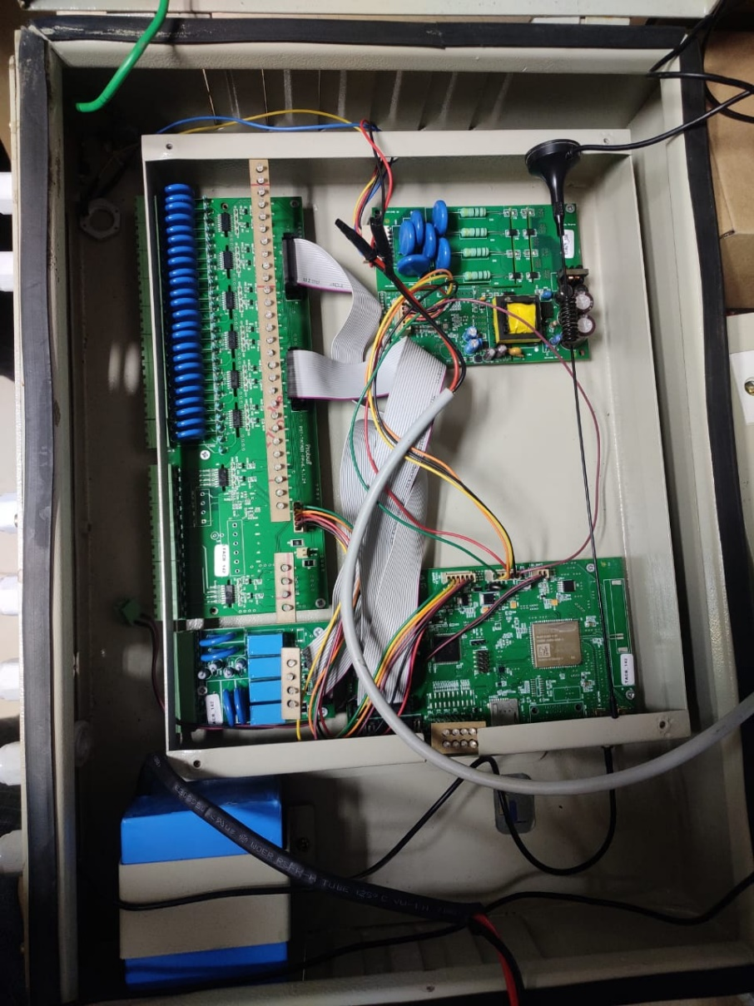

MASTER PCB LED

Fig 3.4 IoT based LT ACB automation device configuration

**3.6** **LV Automation webpage description and photographs**

The web portal criteria required for smooth functioning of the automation system is as follows:

* Approximate 500 user log in is required on the web portal and authorization will be AD credential based.
* There should not any requirement for separate software system.
* The web portal can be accessed through enterprise network as well as outside TPDDL network.
* In case of any abnormality, notification, mail, SMS need to come to user. User can extract historical data from web portal in Excel/CSV format.
* All bar graph, chart , business analytics etc. can be customize in responsive web based software .
* Retention time of the operational data will be 2 years .
* At any point in operation, the data reporting and alert messaging settings for each IOT Device can be individually re-configured via its network interface. The operator can select the device measurement reporting interval from every minute, hour, day or week as needed. Any stored data, including detailed raw measurement data can be retrieved, for instance if detailed analysis of a specified timed event or period is required.
* Responsive web application to be develop to get real time notification and check the device status. Digital Data and Fault current data measurement will be real time basis.

1. District wise LTACB/Fuse Alerts

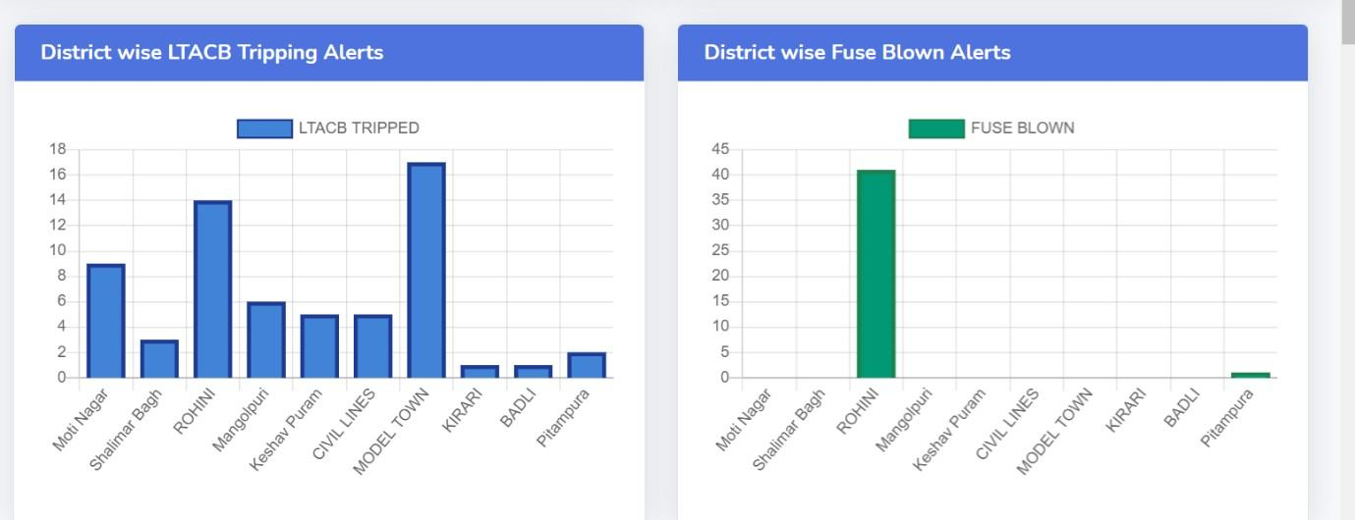Fig 3.5 District wise LTACB/Fuse Alerts

It shows all the open alerts in different Districts.

Data can be filtered in exported sheet and reasons for tripping can be seen thereby.

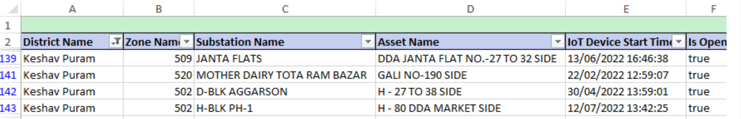  
Fig 3.6 Exported device data sheet

1. District/Circle wise MTTR for LTACB Tripping/FUSE Blown

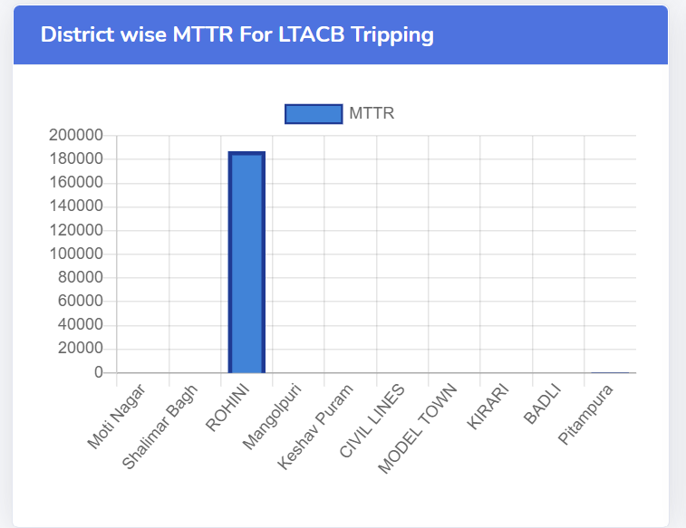

Fig 3.7 MTTR bar graph for LTACB tripping

It shows the duration of all close alerts in a single district/circle on a particular date.

1. Top 5 Zone with highest LTACB Tripping/ Fuse Blown

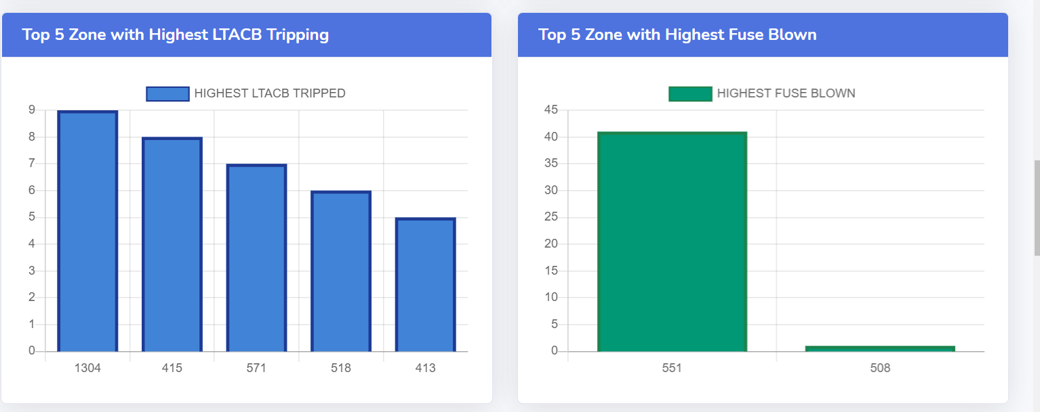

Fig 3.8 top 5 tripping zones

It shows the 5 zones which have highest alerts

1. District wise LTACB/FEEDER PILLAR device Status

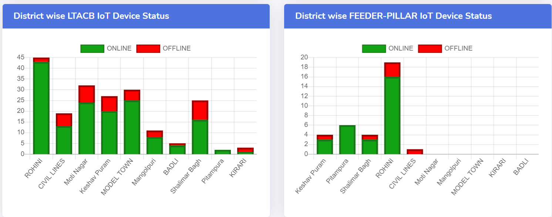

Fig 3.9 online/offline device count

It shows the total count of online/offline status.

**5.** IoT device pin mapping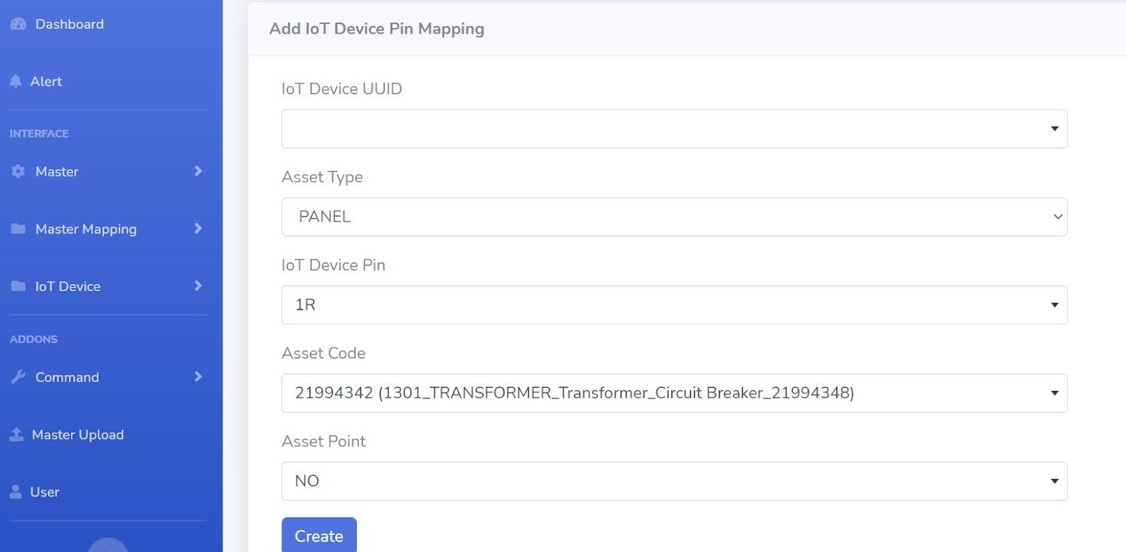

Fig 3.10 pin mapping

It has 5 fields –

1. **IoT Device UUID** – enter the UUID of the Device.
2. **Asset type** – Enter the asset type like PANEL , DT, LTACB and FEEDER PILLAR

3. **IoT Device Pin –** Enter the pin which is mapped with physical hardware

4. **Asset Code –** Enter the code of device which is registered in master

5. **Asset Point** – It is the point of configuration the pin like R,Y,B for LTACB and NO NC for Panel and Relay for Relays and FUSE for Fuses.

After filling the details of the device just click on the create button. Your device is registered now.

**6.** How to see the details of Device

when you click on details then it shows all details as shown in the following figure.

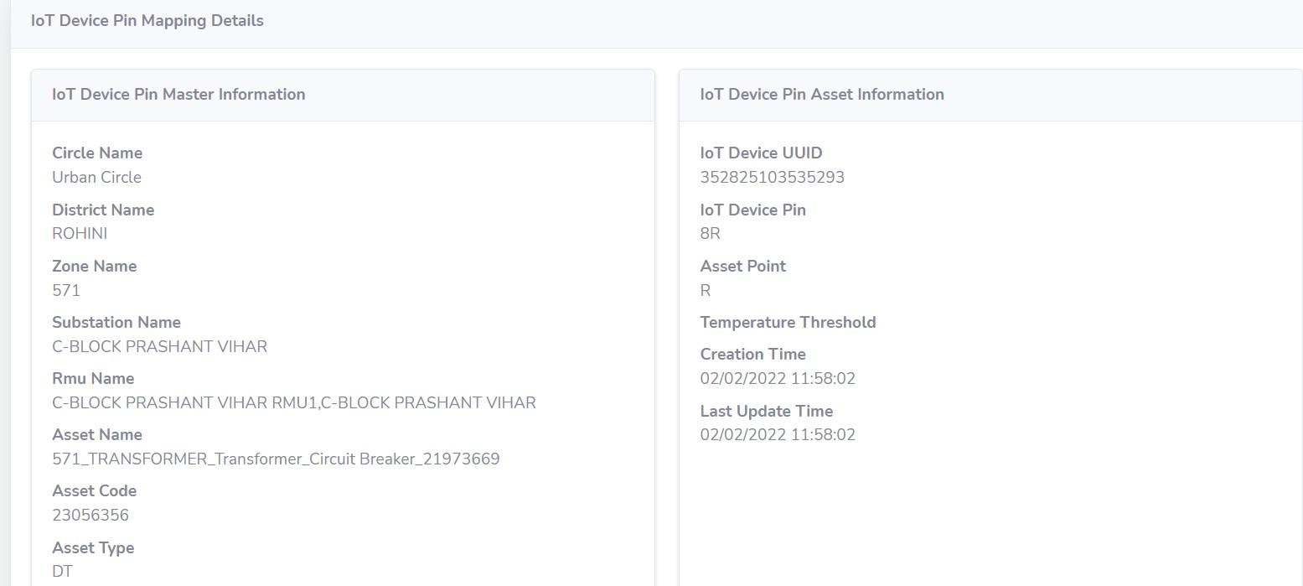  
Fig 3.11 Device details

**7**. How to see Device data

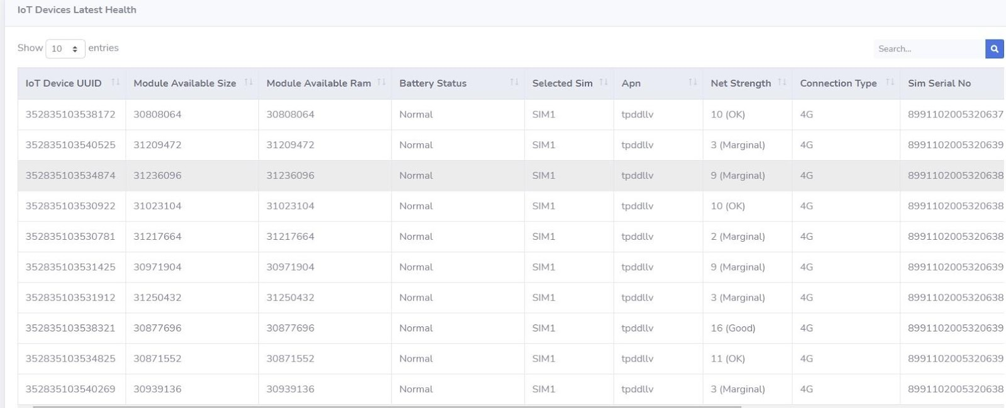  
  
  
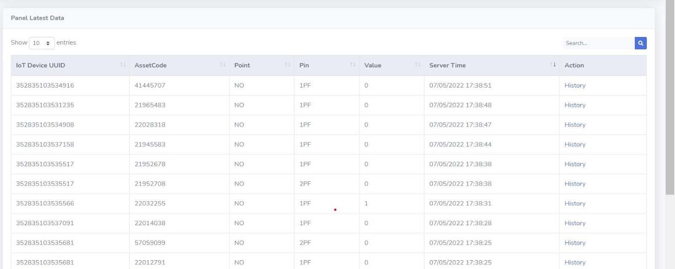

Fig 3.12 Device latest health status

Device data gives the value in 0 and 1 in which 0 shows normal and 1 shows alert condition.

**7**. Device summary

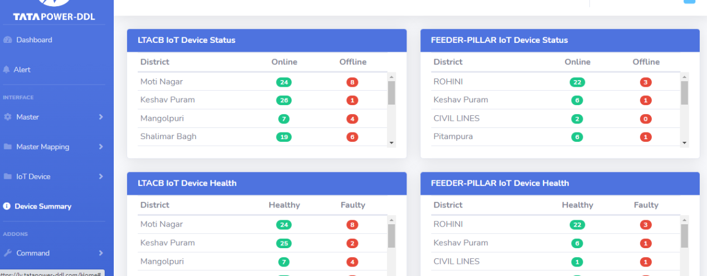

Fig 3.13 Device summary

Tells the actual no of online/offline devices along with other sensors status like health, temperature etc.

**8**. Master mappings

We can create a new circle and subsequent ltacb/fp mapping using the following hierarchy, keeping in mind the unique code and Alias no.

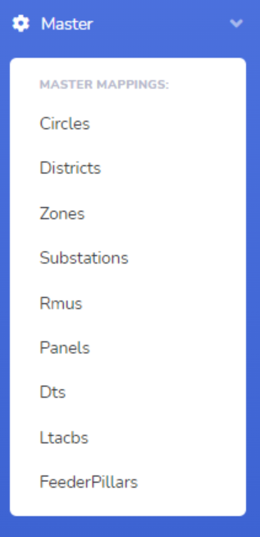

Fig 3.14 Master mapping hierarchy

**3.7** **LV automation site photographs**

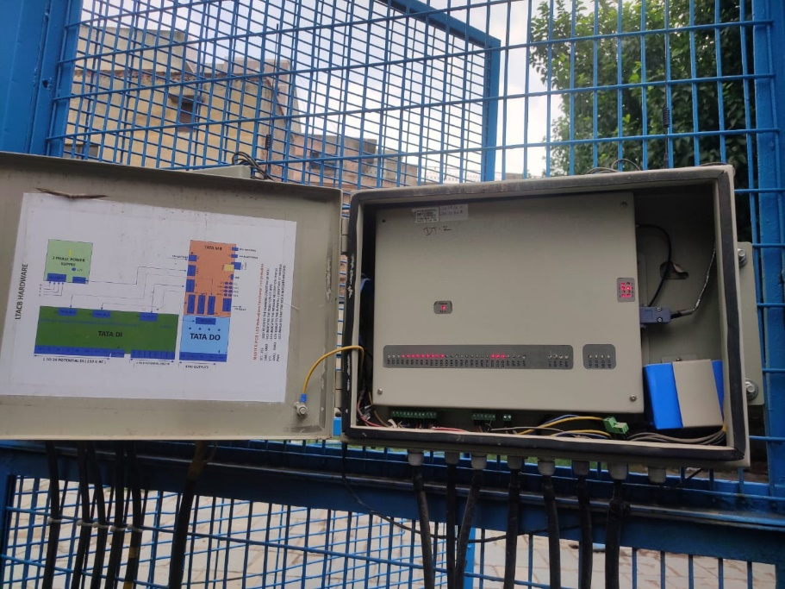

Fig 3.15 IoT device troubleshooting

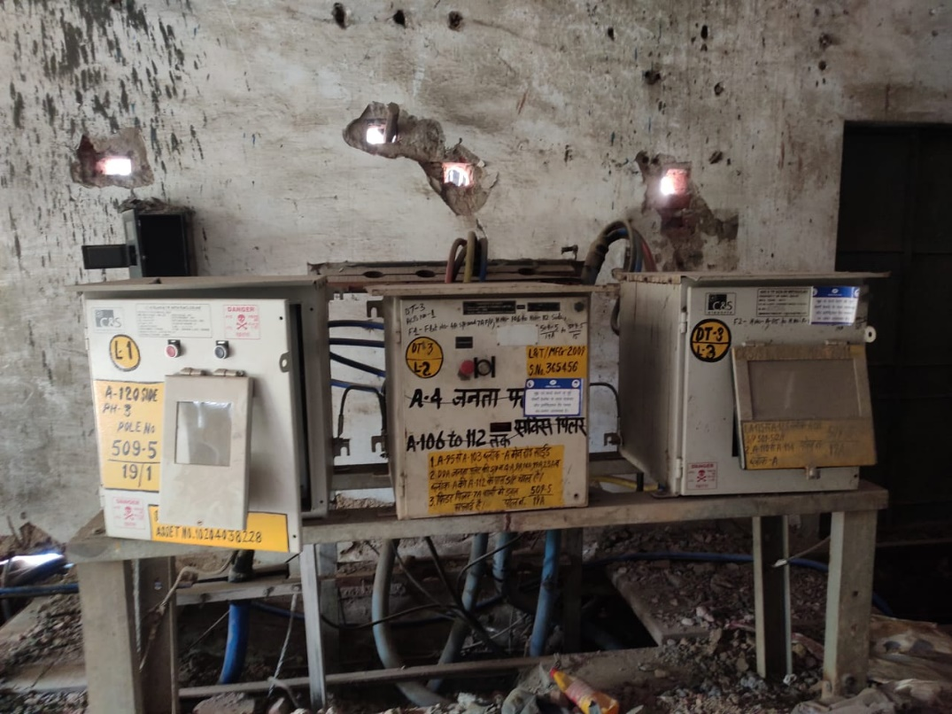

Fig 3.16 LT ACBs

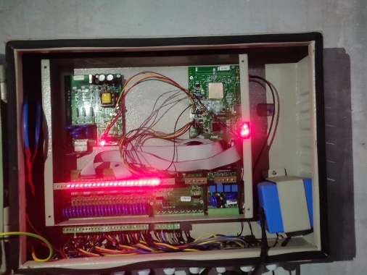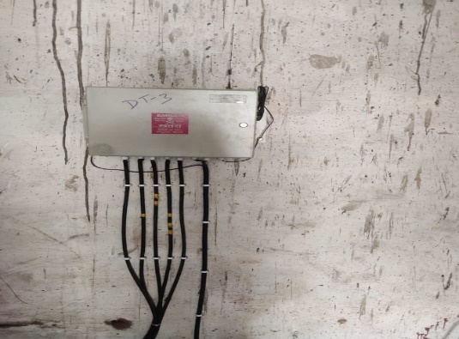

Fig 3.17 Live IoT device at the site

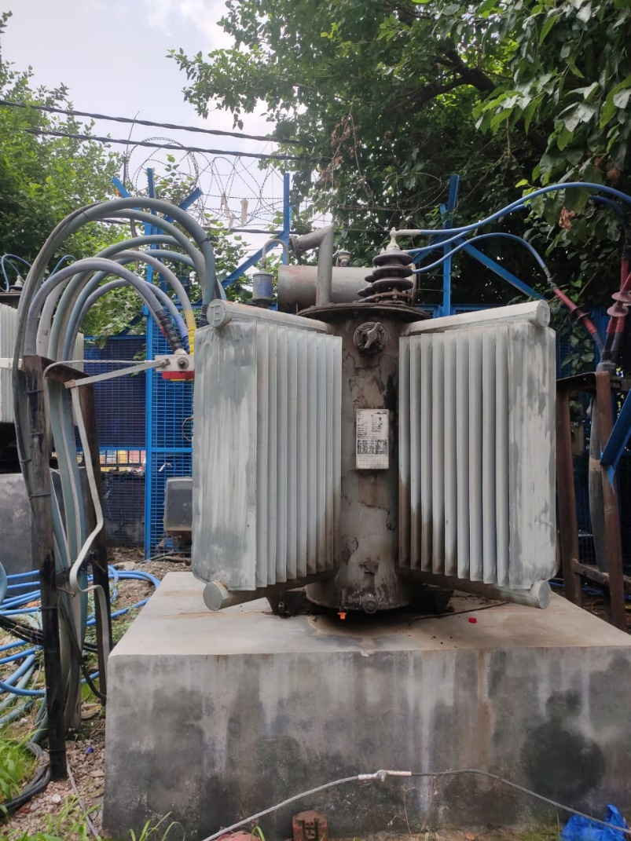

Fig 3.18 Distribution transformer

Distribution transformers are used for lower voltage distribution networks as a means to end user connectivity. The power rating is normally determined by the type of cooling methods the transformer may use.

**3.8** **LV automation X-CTU website for troubleshooting**

XCTU is a free multi-platform application designed to enable developers to interact with Digi RF modules through a simple-to-use graphical interface.

Command list used at site while trouble shooting:

|  |  |  |
| --- | --- | --- |
| S.NO | COMMAND | PURPOSE |
| 1 | At | for checking device status |
| 2 | at+creg? | Networks check |
| 3 | at+ccid? | Sim No Check |
| 4 | at+cgpaddr | for checking SIM static IP |
| 5 | at^smoni | .2g/3g/4g Network check |
| 6 | at+csq | Network strength check |
| 7 | at+cgsn | for checking of UUID |
| 8 | at^sjam=1 | for running new file |

Table 3 command list for X-CTU

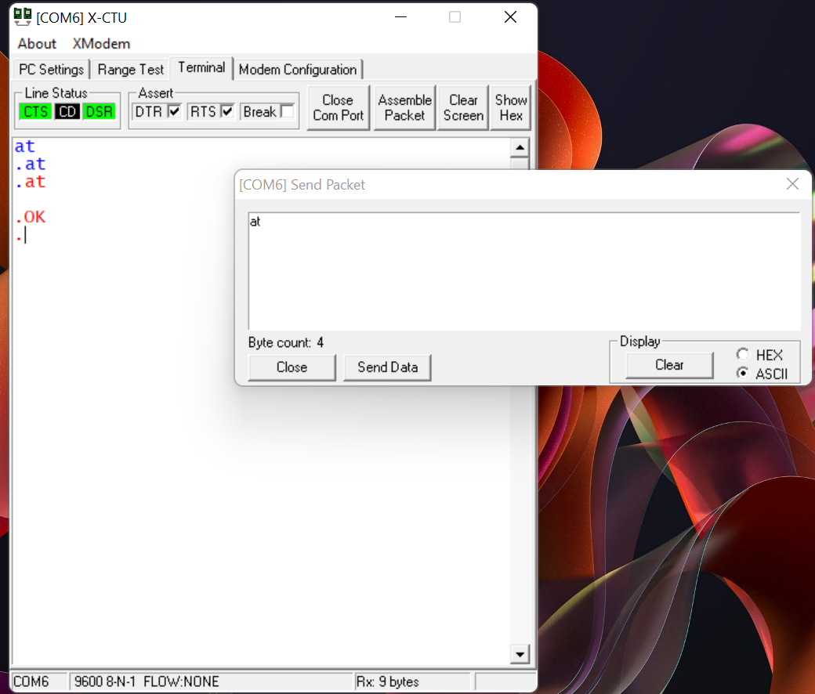

Fig 3.19 Terminal and command window

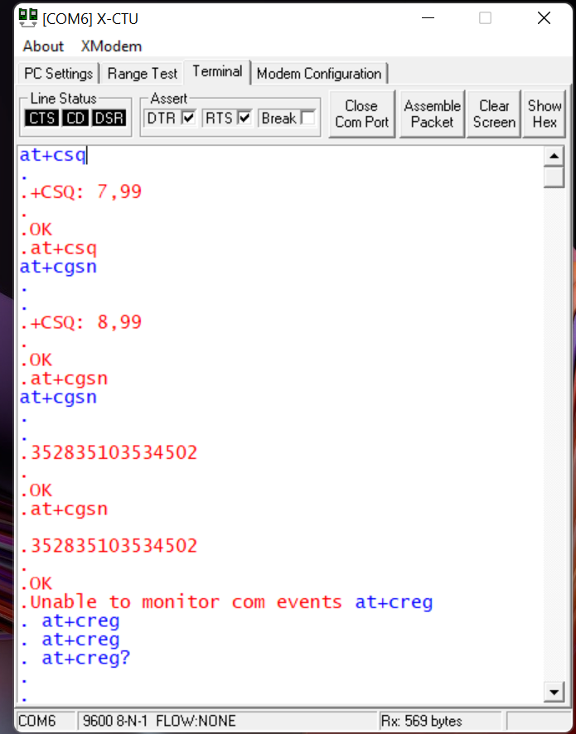

Fig 3.20 Network Strength and device UUID

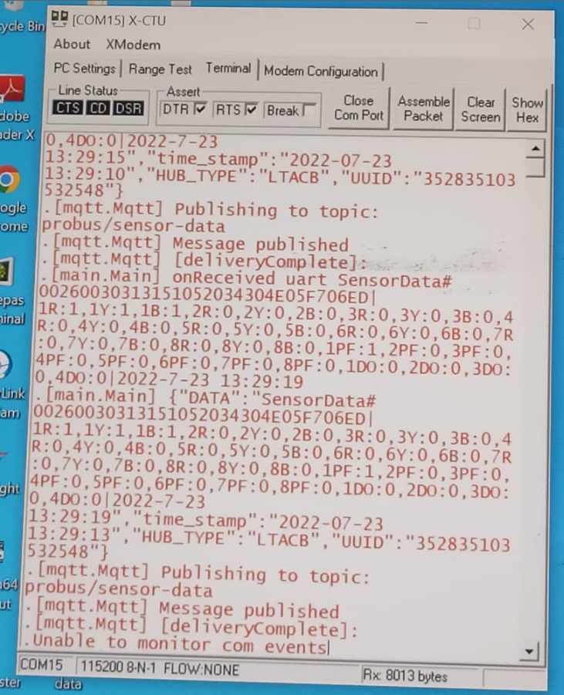

Fig 3.21 Running file to check published and received sensor data

**4.Benefits of IoT in LV automation**

Following the architecture of the distribution community IoT platform, the construction of distribution IoT application scenarios based on station area intelligent perception devices is carried out, guided by the application requirements in the distribution of electricity. From the perspective of professional application of distribution network equipment, the data application of the station area intelligent perception device is divided into three categories according to scenarios: lean operation and inspection of distribution network equipment, quality service for marketing customers, and new energy consumption and new load management.

**4.1 MTTR reduction**

MTTR (mean time to recovery or mean time to restore) is the average time it takes to recover from a product or system failure. This includes the full time of the outage—from the time the system or product fails to the time that it becomes fully operational again.

IoT Enable engineers with interactive automation and real-time intent visualization with its robust incident-management action plan. The Internet of Things (IoT) refers to products that are always connected to the internet, streaming behavior-related information and other data. Vendors of these products then analyze the data and draw insights to achieve multiple benefits. Observability allows teams to monitor modern systems more effectively and helps them to find and connect effects in a complex chain and trace them back to their cause.

IoT-based predictive maintenance allows you to systematically schedule the optimal maintenance and inspection routine to avoid unplanned downtime and unnecessary effort. Avoidable costs can be reduced greatly and you can also reduce the amount of time the machinery or equipment is down for maintenance.

**4.2 Predictive Analysis**

Lean operation and inspection of distribution network equipment improves the station area operation monitoring capability.

In addition to the traditional monitoring on the station side, it also extends to the low-voltage line side and customer side, accessing about 200 devices in total. On the basis of the extended scope, the data collection frequency has been comprehensively improved, and low-voltage alarm information can be obtained in seconds in key areas and within 1–5 min in other areas, and the collection cycle of normal data is compressed to within 15 min.

**4.3 Improves SAIDI**

SAIDI refers to “System Average Interruption Duration Index.” It is calculated by multiplying the average duration of customer interruptions by their total number and then dividing by the total number of customers in the system. Logically, improved response to outages is the most direct way to improve SAIDI. The ability of IoT to network reclosers with communications to create self-healing distribution networks can help limit the number of customers that experience a power outage from random events .Intelligent communication networks like IoT provide high value today by reducing outages and enabling proactive maintenance supported by data analytics.

**4.3 Fault prediction**

It has great significances for predicting faults based on monitoring a long sequence in advance, so as to ensure the safe operation of the power system. The aim of fault prediction is to forecast faults that occur in the power system by analysing historical data, so as to prevent electrical accidents and ensure system recovery. Comprehensive monitoring by IoT sensors at the sites linked with central database helps in hardware fault prediction at sites. Fault and stability diagnosis is really important to ensure smooth functioning of automation in low voltage levels.

**4.4 Minimization of AT&C Loss**

AT&C Loss = (Energy input – Energy billed) * 100 / Energy input. Technical loss depends upon losses incurred from machinery (Transformers), lines and improper maintenance of plant and machinery etc. By taking care of these areas, we can reduce these technical losses. By improving the data collection of energy usage, machine performance, and energy production parameters, IoT based LV automation can help us in reducing the unwanted technical loss.

**5. CONCLUSION**

In this report, I have presented the formal model of IoT based LV automation whose obligation is to utilize the current state-of-the-art technologies in better sensing, detecting, communicating, and controlling the LT ACBs ,panels ,DTs and feeder pillars , especially the Low voltage distribution network layer, to make the supply system robust, efficient, and resilient. IoT is becoming more and more popular by providing digitalized solutions responsive to Industry 4.0 age and having the capability to interact with SCADA systems. At this point, IoT systems need to be positioned as something that will take SCADA to the next level rather than being positioned as the competitor of SCADA systems. Using these two systems together to provide better results in industrial areas rather than fighting each other creates wiser results.  the biggest advantage is that it can provide wireless solutions with the flexibility that SCADA cannot provide.

The system helps to ensure the correct and cost-effective functioning of the system at the user end as well as service-provider end. There are some of the challenges faced by this system like internet disconnectivity in remote areas , Device burnouts due to excess load current, infrastructural unavailability and data security and this has to be resolved in efficient manner to ensure customer satisfaction.

**6.REFERENCES**

1. <https://www.automationanywhere.com/company/blog/rpa-thought-leadership/understanding-the-internet-of-things-iot-and-its-connection-to-automation>
2. <https://www.frontiersin.org/articles/10.3389/fenrg.2022.902715/full>
3. <https://www.geeksforgeeks.org/internet-things-iot-2/>
4. <https://www.nema.org/directory/products/view/distribution-automation>